Dear ________________________________,

Guess what? I ___________________ you so much that I am giving you this letter. This is a really ___________________ thing for me to do, because I ______________________ that you’ll be _________________________. I am doing this because it is very important to me.

Here it goes. Guess what? I’m
Gay Queer Lesbian Bisexual Asexual
Pansexual Heterosexual
Transgender Non-binary Genderqueer
Not a ________________________ Magically undefinable
Questioning my identity as ____________________
_________________________________

You might be thinking,
How can you be sure? You’re not old enough to know that.
This is just a phase; you’ll grow out of it. I am so scared for you!
WHAT????? BUT YOU’RE __________________________________________________!!!
Not in my house you aren’t! Yeah, I figured.
Well, duh! Hooray!
I will always love you! How can I help protect you?

I promise you, I have been considering this for myself for __________________________________ and have really thought about __________________________________________________________
_____________________________. I am personally still figuring out ______________________________________________________________________________________________________________________________________________________________________________________.

I hope you take a moment to consider how you respond. It will really hurt me if you say:
You’ll only love me as the way you thought of me before
You think God didn’t make people like me
You think my friends are influencing me and I don’t know
how to make big “choices” like this
You never want to see me again
You think someone hurt me to make me this way

I would love to hear you say:
I love you no matter who you are I will support you through this
I knew it all along Your secret’s safe with me
How can I help? It’s time for a celebration!

I’d be totally willing to talk about the following things:
How you can support me What the word or identity means
How I came to understand this for myself How I’m feeling
What’s cool about being me
What kinds of support I need, like groups, counseling, school advocacy, or medical care
_____________________________________________________________________

It’d be hard, but I’m willing to talk about:
Your concerns about my future How I came to understand this for myself
How I’m feeling Your beliefs about being this identity
What kinds of support I need, like groups, counseling, school advocacy, legal changes, or medical care

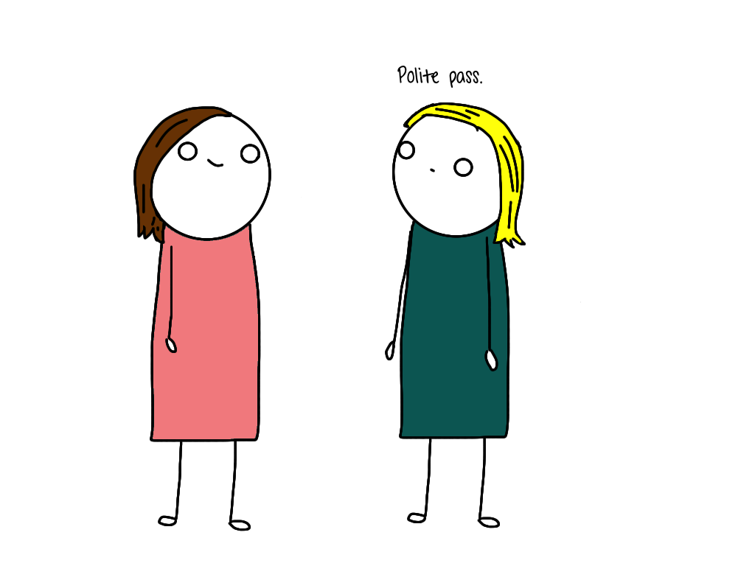
I’d like to request that if you need to talk about the following, that you find someone else to talk to:
Your concerns about my future
Your beliefs about being this identity
How someone “becomes” this identity
Any really private questions like about my body or my romantic
relationships
All the scary or negative things you might be thinking about my future

I hope that after you read this, we __________________________________________________________________________________.

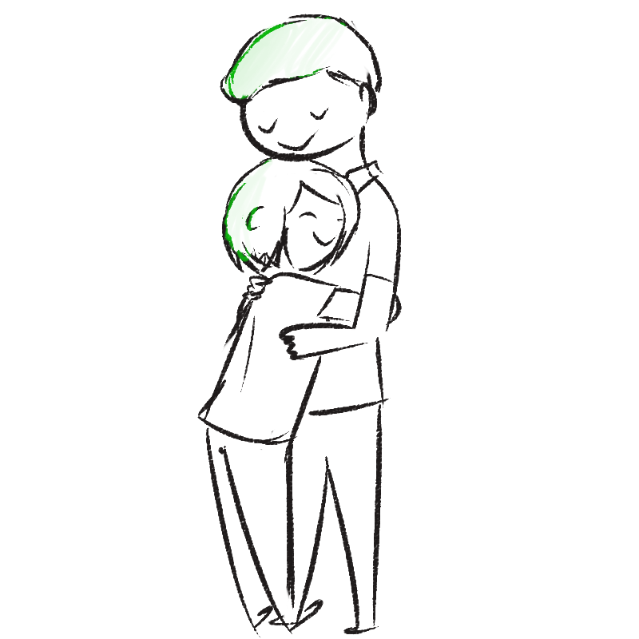
Thank you for
Listening to me
Believing in me
Being there for me no matter what
Keeping this private until I say we can tell other people.

I ______________________________ you,

______________________________________________
(your name)

